AI Application Architecture
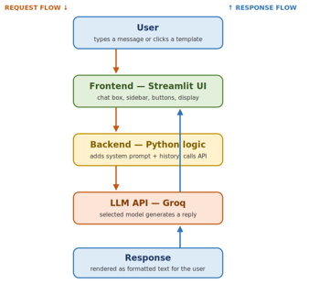

Request Flow
The request flows top to bottom. The user types a message in the chat box or clicks a template button. The Streamlit frontend captures that input and passes it to the Python logic in the same file. The logic then builds the full request: it puts the system prompt first, adds the whole conversation history, and attaches the chosen model. This complete request is sent to the Groq LLM API, which runs the selected model on it.

Response Flow
The response flows back up. The Groq API returns a structured object containing the model's reply. The Python logic reads the text out of it (from response.choices[0].message.content), saves it to the conversation history so it is remembered, and hands it to the Streamlit UI. The UI renders it as formatted markdown in an assistant chat bubble, so the user sees a clean, readable answer.

Error Handling
The API call is wrapped in a try/except block. If anything goes wrong, a wrong API key, a lost internet connection, or hitting the free rate limit, the error is caught instead of crashing the app, and a clear red message is shown to the user. Empty messages are also handled: because the send only runs when there is actual input, pressing send on an empty box simply does nothing. This keeps the app stable no matter what.

API Integration
The app connects to the model through the OpenAI Python library. A client object is created once with the API key and a base_url pointing at Groq's server. Groq exposes an OpenAI-compatible endpoint, so the same standard library works without changes, only the address differs. Each message calls client.chat.completions.create() with the model name and the message list. Because the whole conversation is resent every time, the otherwise stateless model appears to remember the chat. Switching providers later would only require changing the base_url and key.

